YOLO11 Instance Segmentation - Documentation
This project trains a YOLO11 instance segmentation model for vehicle-part mask prediction. The results documented here are taken from the current local run artifacts in runs/segment/train/, especially results.csv and args.yaml.

What This Model Does
The model predicts instance masks for 9 vehicle-part classes:
Class | Annotation count
fog lights | 514
headlight | 1,203
plate | 372
rear window | 69
side mirror | 1,119
tail lights | 270
tires | 1,952
window | 2,022
windshield | 962
Total labeled instances across all splits: 8,483.

Project Layout
3. Segmentation/
|-- check_dataset.py
|-- dataset/
| |-- data.yaml
| |-- data.train_resolved.yaml
| |-- train/images/ and train/labels/
| |-- valid/images/ and valid/labels/
| `-- test/images/ and test/labels/
|-- predict.py
|-- README.md
|-- runs/segment/
| |-- predict/
| | |-- labels/
| | `-- annotated prediction images
| |-- train/
| | |-- args.yaml
| | |-- results.csv
| | |-- results.png
| | |-- confusion_matrix.png
| | |-- confusion_matrix_normalized.png
| | |-- Box*.png and Mask*.png curves
| | |-- train_batch*.jpg and val_batch*_*.jpg
| | `-- weights/best.pt and weights/last.pt
| `-- val/
|-- train.py
`-- yolo11n-seg.pt
Note: dataset/, runs/, .venv/, and *.pt files are ignored by git in this folder. The documentation references local artifacts that exist on this machine. If this project is shared, export the run artifacts separately.

Dataset Summary
Dataset source metadata in dataset/data.yaml:
Field | Value
Format | YOLO instance segmentation, data.yaml plus polygon labels
Roboflow project | segmentation-adhao
Roboflow version | 1
Number of classes | 9
Split quality checks from the current local dataset:
Split | Images | Label files | Instances | Empty labels | Missing labels | Orphan labels
Train | 627 | 627 | 7,417 | 0 | 0 | 0
Valid | 60 | 60 | 715 | 0 | 0 | 0
Test | 30 | 30 | 351 | 0 | 0 | 0
The dataset is structurally clean: every image has a matching label file and no orphan label files were found.
A segmentation label row has this format:
class_id x1 y1 x2 y2 x3 y3 ...
Each polygon must contain at least 3 (x, y) points, and all coordinates should be normalized from 0 to 1.

Environment
This folder uses its own Python virtual environment:
cd "3. Segmentation"
.\.venv\Scripts\python.exe -c "import torch; print(torch.cuda.is_available())"
Expected GPU result: True when CUDA-enabled PyTorch is installed. CPU training also works but is slower.

Training Configuration
The current run was launched by train.py and saved to runs/segment/train/. The full resolved configuration is saved in runs/segment/train/args.yaml.
Setting | Value
Task | Segmentation
Base model | yolo11n-seg.pt
Data file used for training | dataset/data.train_resolved.yaml
Original data file | dataset/data.yaml
Configured epochs | 100
Completed epochs in log | 90
Image size | 640
Batch size | 8
Early stopping patience | 25
Device | 0 GPU
Optimizer | auto
AMP | true
Seed | 0
Output folder | runs/segment/train/
train.py writes data.train_resolved.yaml before training so YOLO receives absolute, existing image paths for train, val, and test.
Run training:
cd "3. Segmentation"
.\.venv\Scripts\python.exe train.py
train.py validates the dataset first by calling check_dataset.py. If blocking errors are found, training stops before any GPU time is spent.

Training Results
Primary metric: mAP50-95(M). This measures mask quality over multiple IoU thresholds from 0.50 to 0.95. Box metrics are also logged because the model learns boxes around each mask.
Metric | Best mask epoch 65 | Final epoch 90
Box precision | 0.8101 | 0.8053
Box recall | 0.7488 | 0.7835
Box mAP50 | 0.8086 | 0.8043
Box mAP50-95 | 0.6405 | 0.6346
Mask precision | 0.7803 | 0.7948
Mask recall | 0.7541 | 0.7802
Mask mAP50 | 0.7861 | 0.7916
Mask mAP50-95 | 0.5870 | 0.5776
The best checkpoint is:
runs/segment/train/weights/best.pt
Use best.pt for inference unless you specifically need the final checkpoint last.pt. Both checkpoint files are about 5.74 MB.

Result Figures
Training curves:
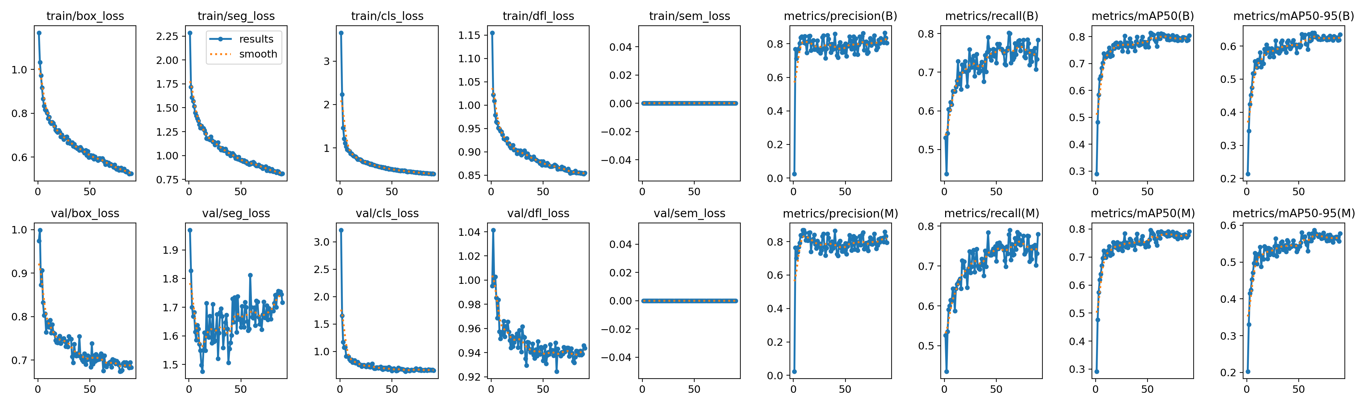
Training results
Confusion matrix:
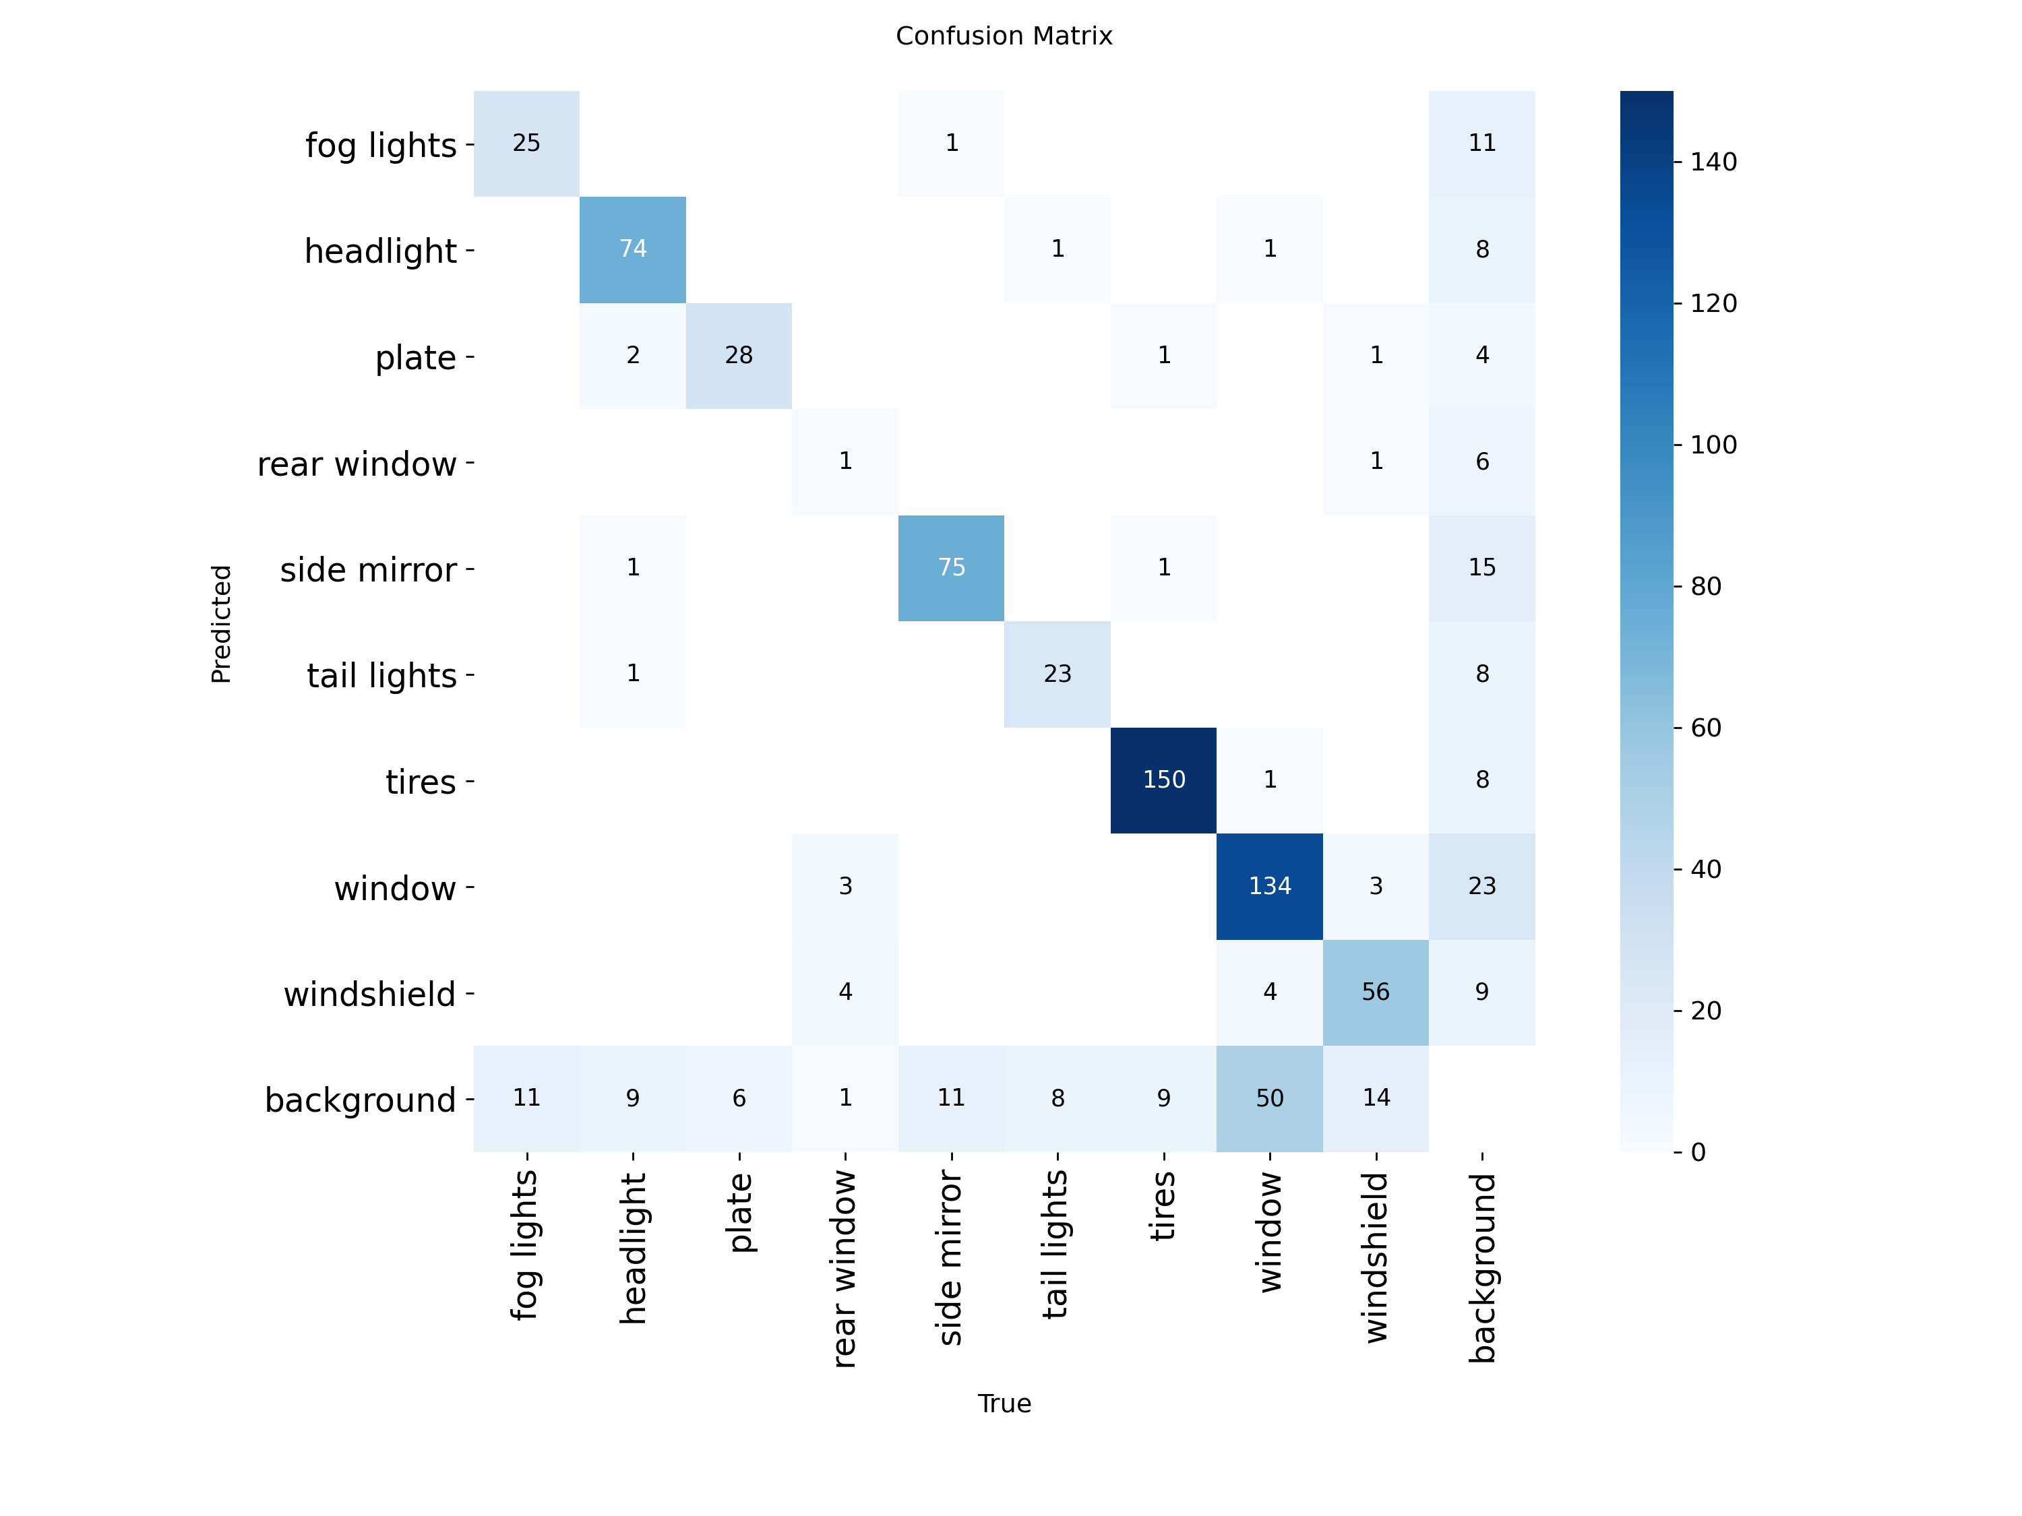
Confusion matrix
Normalized confusion matrix:
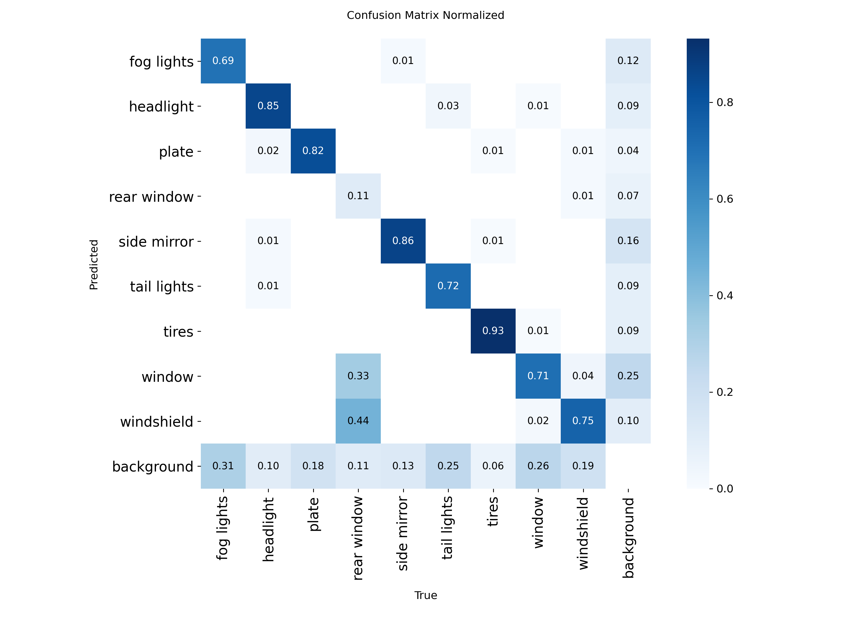
Normalized confusion matrix
Mask precision-recall curve:
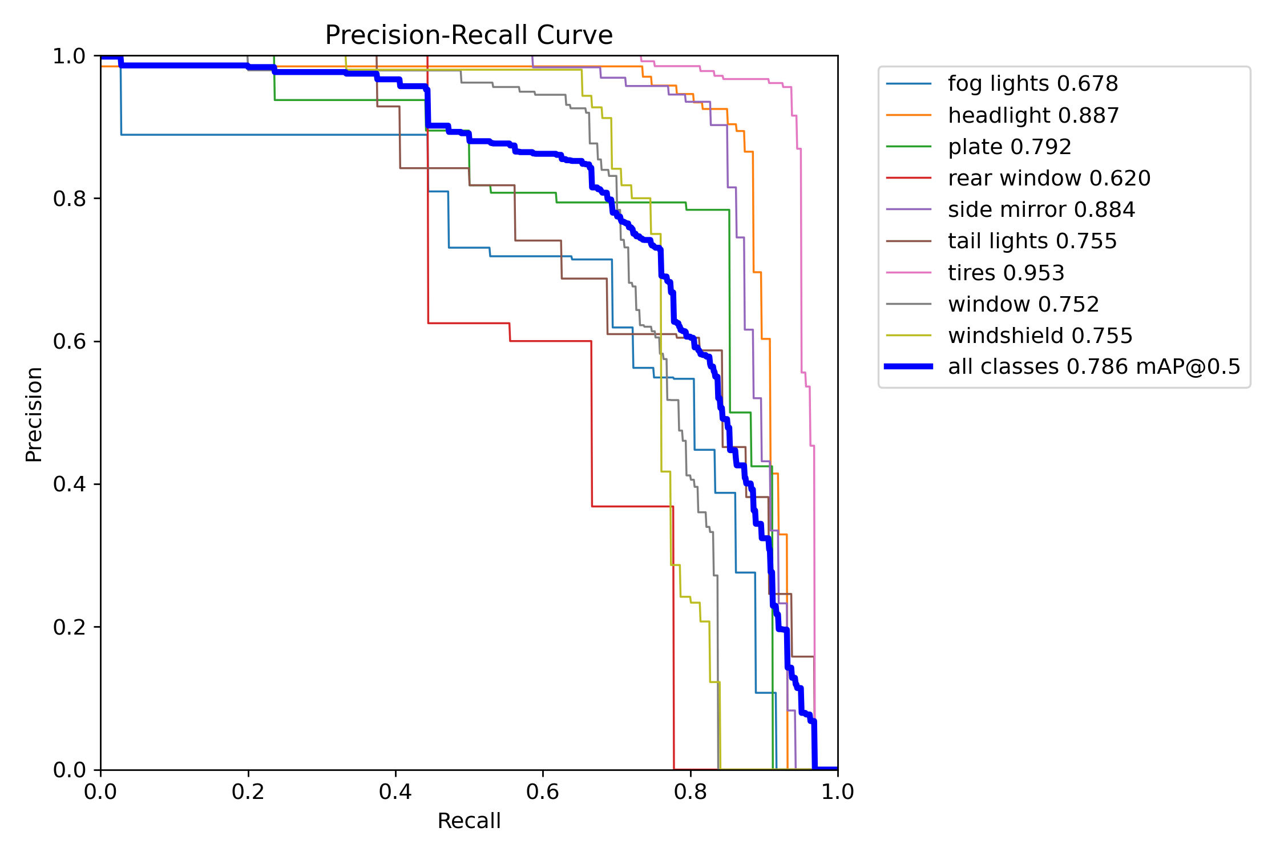
Mask precision-recall curve
Box precision-recall curve:
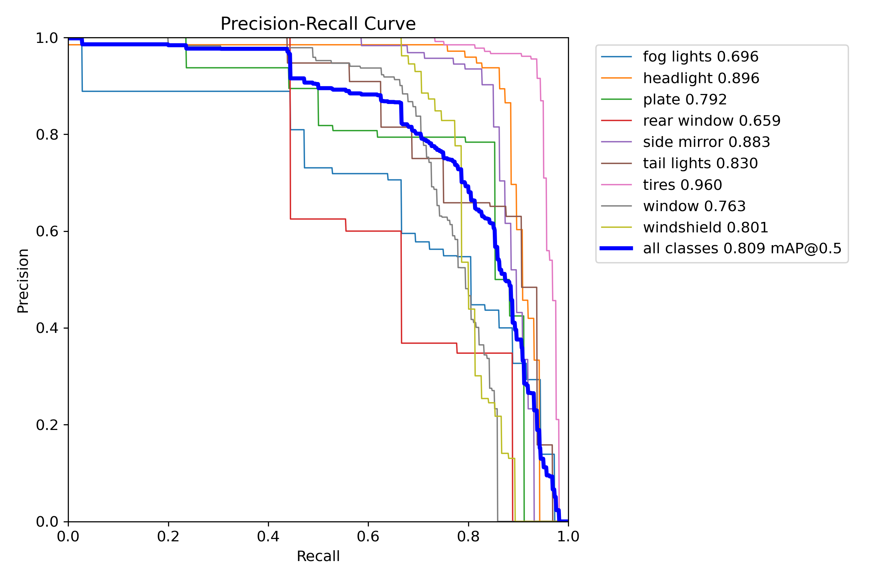
Box precision-recall curve
Additional curves available in the run folder:
File | Meaning
BoxP_curve.png | Box precision at confidence thresholds
BoxR_curve.png | Box recall at confidence thresholds
BoxF1_curve.png | Box F1 score at confidence thresholds
BoxPR_curve.png | Box precision-recall tradeoff
MaskP_curve.png | Mask precision at confidence thresholds
MaskR_curve.png | Mask recall at confidence thresholds
MaskF1_curve.png | Mask F1 score at confidence thresholds
MaskPR_curve.png | Mask precision-recall tradeoff
labels.jpg | Label distribution and mask/box distribution
train_batch*.jpg | Augmented training batch samples
val_batch*_labels.jpg | Validation images with ground-truth masks
val_batch*_pred.jpg | Validation images with predicted masks

Validation Run Artifacts
runs/segment/val/ exists and contains a validation artifact set generated from model validation:
Artifact type | Files
Box curves | BoxP_curve.png, BoxR_curve.png, BoxF1_curve.png, BoxPR_curve.png
Mask curves | MaskP_curve.png, MaskR_curve.png, MaskF1_curve.png, MaskPR_curve.png
Confusion matrices | confusion_matrix.png, confusion_matrix_normalized.png
Validation examples | val_batch0_*, val_batch1_*, val_batch2_*
Use the train/ folder for the logged training history. Use the val/ folder to inspect a separate validation visualization pass.

Inference
The inference script uses:
Setting | Value
Weights | runs/segment/train/weights/best.pt
Source | dataset/test/images
Confidence threshold | 0.25
Image size | 640
Output folder | runs/segment/predict/
Text output | save_txt=True, save_conf=True
Run prediction:
cd "3. Segmentation"
.\.venv\Scripts\python.exe predict.py
The current local prediction folder contains:
Output | Count | Location
Annotated images | 30 | runs/segment/predict/
Prediction text files | 30 | runs/segment/predict/labels/
Prediction text files contain the class id, normalized polygon coordinates, and confidence value for each predicted instance.

How To Read The Metrics
Metric | Meaning
Box precision | Of predicted boxes, how many were correct
Box recall | Of real objects, how many boxes were found
Box mAP50-95 | Box quality averaged across IoU 0.50 to 0.95
Mask precision | Of predicted masks, how many were correct
Mask recall | Of real masks, how many masks were found
Mask mAP50-95 | Mask quality averaged across IoU 0.50 to 0.95
Seg loss | Mask segmentation loss; lower is better
Box/Class/DFL losses | Detection-related losses; lower is better
For this project, report mAP50-95(M) = 0.5870 from epoch 65 as the best mask validation result. The final epoch had slightly higher mask recall but lower mask mAP50-95, so best.pt remains the safer inference checkpoint.

Dataset Validation
Run the checker directly:
cd "3. Segmentation"
.\.venv\Scripts\python.exe check_dataset.py
The checker verifies:
- data.yaml exists and defines class names.
- train, valid, and test splits have matching images/ and labels/ folders.
- Every image has a matching label file.
- Label files have valid YOLO polygon rows.
- Each polygon has at least 3 point pairs.
- Class ids are valid and coordinates are normalized from 0 to 1.
- Every class appears in the annotations.

Troubleshooting
Problem | Fix
CUDA out of memory | Lower BATCH from 8 to 4 or 2 in train.py.
Training is too slow | Use GPU device 0; reduce IMG_SIZE to 512 if acceptable.
Dataset validation fails | Fix malformed polygon rows, missing labels, or invalid class ids reported by check_dataset.py.
Predictions have boxes but poor masks | Prioritize mask curves and MaskPR_curve.png, not only box metrics.
Prediction text files are missing | Confirm save_txt=True and save_conf=True in predict.py.

Reproducible Workflow
cd "3. Segmentation"
.\.venv\Scripts\python.exe check_dataset.py
.\.venv\Scripts\python.exe train.py
.\.venv\Scripts\python.exe predict.py
Report the model using the best-validation result: mAP50-95(M) = 0.5870 at epoch 65.

